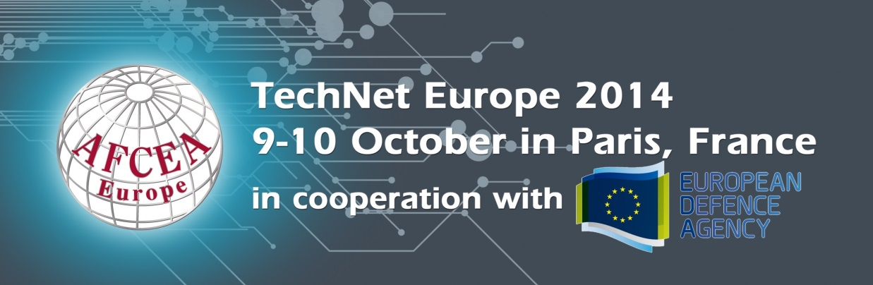
FREQUENTLY ASKED QUESTIONS
ACCOMMODATION

Participants are responsible for their own travel and accommodation arrangements and payment.

The Hotel du Collectionneur is the event venue and the official hotel of TechNet Europe 2014. Special preferential rates have been negotiated for participants of the conference
(350 EUR/night. Fee includes breakfast and taxes, free Wi-Fi access and free access to the spa).
The deadline for accommodation booking is BEFORE Monday 8 September. After this date, availability of rooms and the negotiated rates cannot be guaranteed.

IMPORTANT: The conference will take place during a high hotel room occupancy time in Paris. The city hotel rooms are already more than 40% booked during this period. Therefore we encourage you to book your accommodation immediately.

Accommodation booking form is available, click here.

If you prefer to download the Individual reservation form, please click here.

L’Hôtel du Collectionneur (Conference Venue)
51-57 rue de Courcelles
75008 Paris
France

Tel : +33 (0)1 58 36 67 00
Fax : +33 (0)1 58 36 67 77
Website

Located in the 8th arrondissement, Champs Elysées area, The Hotel du Collectionneur faces the very chic Parc Monceau, just a few minutes from the Arc de Triomphe, Avenue des Champs Elysées, the boutiques and art galleries of the rue du Faubourg Saint Honoré.
Check-in: 4:00PM
Check-out: 12:00PM
ACCESS & TRANSPORTATION TO THE VENUE

ACCESS TO THE VENUE:

- Metro stops: “Courcelles” or “Ternes” (line 2), “Miromesnil” or “Saint-Philippe-du-Roule” (line 9)

- Bus Line 84: “Murillo” stop

INTERACTIVE MAP OF PUBLIC TRANSPORTS IN PARIS (RATP)

- Train stations:
  - Gare Saint Lazare (5 minutes’ taxi drive)
  - Gare de l’Est, Gare du Nord, Gare Montparnasse, Gare de Lyon & Gare d’Austerlitz (20 minutes’ taxi drive)

- Airports: Roissy Charles de Gaulle & Orly: 40 minutes’ taxi drive

- Public parking: 80 vehicles with direct access to the hotel. Cost: +/-35 EUR per 24 hrs.
Other public parking, click here

FROM AIRPORTS:

Roissy Charles de Gaulle:
- Taxi (+/- 40 min.) Cost: +/- 50 EUR

- RER+Metro (+/- 1 hr):
Take RER B Direction “Robinson” (B2) or Direction “Saint Rémy les Chevreuses”
(B4) to “Gare du Nord”. In “Gare du Nord” take Metro line 2 Direction “Porte
Dauphine” and stop at “Courcelles”.

Cost: +/- 10 EUR

- Airport Bus (Air France) (+/- 1 hr):
Take Air France Bus and stop at "L'Arc de Triomphe" on Avenue Carnot. The
Hotel du Collectionneur is about 900 meters’ walk from this stop.

Cost: +/- 15 EUR/person

Orly:
- Taxi (+/- 40 min.) Cost: +/- 35 EUR

- Airport Bus (Orly bus)+Metro (+/- 1 hr):
Take the Orly bus and stop at “Denfert-Rochereau”. From
“Denfert-Rochereau”, take Metro line 6 Direction “Charles de Gaulle-Etoile” until
terminus. From “Charles de Gaulle-Etoile”, take Metro line 2 Direction “Nation”
and stop at “Courcelles”.

Cost: +/- 10 EUR (Orly bus+metro ticket)

FROM TRAIN STATIONS:
Paris Gare du Nord:
- Taxi (+/- 20 min.) Cost: +/- 45 EUR

- Metro (+/- 20 min.):
Take Metro line 4 Direction “Porte de Clignancourt” and stop at “Barbes-
Rochechouart”. From “Barbes-Rochechouart”, take Metro line 2 Direction
“Porte Dauphine” and stop at “Courcelles”.

Cost: +/- 1,70 EUR

Paris Gare de Lyon:
- Taxi (+/- 20 min.) Cost: +/- 45 EUR

- RER+Metro (+/- 20 min.):
Take RER A Direction “Saint-Germain-en-Laye” (A1) or Direction “Cergy Le
Haut” (A3) or Direction “Poissy” (A5) and stop at “Charles de Gaulle-Etoile”.
From “Charles de Gaulle-Etoile”, take Metro line 2 Direction “Nation” and stop
at “Courcelles”.

Cost: +/- 1,70 EUR

ATTENDEE LIST

An attendee list will be available on-site.

CLOAK ROOM

A cloak room will be available at the Hotel du Collectionneur.

Opening hours:

Wednesday 8 October (pre-event day)
1400 - 1930

Thursday 9 October (day 1 of event)
0800 - 1845

Friday 10 October (day 2 of event)
0800 - 1600

CONFERENCE MATERIAL

Your badge and a Final Programme will be distributed on arrival at the AFCEA Europe Registration Desk.

CONFERENCE PAYMENT

When registering and prior to 3 October 2014. Payment can be made by credit card or bank transfer before the event. An invoice will be e-mailed to you or to the contact person named on your registration form.

CONFERENCE NETWORKING RECEPTION

There will be a reception in the exhibition area on 9 October from 1715 to 1815.

CONTACTS

- Exhibition, Sponsorship, logistics: Mandy Rizzo

- Registration, Programme, speaker biographies & abstracts: Linda Guthrie

- General Information, Exhibit/Sponsorship passes, Event Promotion (advertisements, printed programme, website): Elodie Mercier

CURRENCY

France utilizes the Euro (EUR) as their mode of currency. The current exchange rate can be viewed by clicking here. Please note the exchange rate is subject to change.

DRESS CODE

The dress code for the conference is business attire or military uniform.

EXPOSITION SCHEDULE

Thursday 9 October 0830 - 1815

Friday 10 October 0830 - 1600

PRESENTATIONS

The presentations will be available after the event. You will receive link to a secured HTML and a password to have access to the presentations.

PROGRAMME

The Event programme is available, click here

REGISTRATION

ONLINE REGISTRATION IS OPEN, CLICK HERE
Registration fee includes a full-access conference pass, networking lunches, reception on 9 October and coffee breaks.

 | AFCEA Individual Member | Non AFCEA Member
Industry | 625 EUR | 750 EUR
Active Military/Government | 300 EUR | 400 EUR

Important VAT information
- All fees are in Euro and are subject to French VAT of 20%
- NATO personnel and some Diplomatic Missions may be exempt from VAT charges but must provide a VAT Exemption Certificate otherwise VAT will be charged. This document must be provided with registration form.

SHIPMENT

There is a freight forwarder for shipment. Please contact Mandy Rizzo for the Exhibitor Technical Manual.

SPECIAL NEEDS

If you have any special needs, disabilities, and/or dietary restrictions that we may address to make your participation at our event more enjoyable, please do let us know when registering.

SPONSOR/EXHIBITOR

Sponsors and exhibitors may be entitled to a certain number of complimentary conference passes and exhibitor badges as part of their package. Please send the names of these participants to Elodie Mercier.

Be advised that the exposition is in the form of a table-top display (no stands) which includes space for up to two standard size banner roll ups, a table and chairs, and electricity. Please b ring your own electricity leads, adaptors, etc. for a smooth set up.
More information for shipping address will soon be available.

Sponsorships are still available. Please click here to view the sponsorship opportunities. You can contact Mandy Rizzo for more information or call +32 (0) 476 633 187, as well.

TIME ZONE

Paris is one hour ahead GMT and six hours ahead of US EST.

