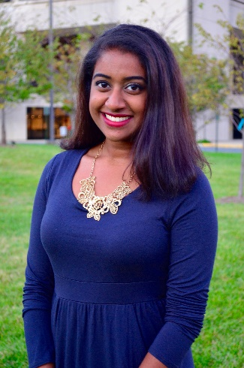
Laahiri Chalasani
As an informal STEM educator, Laahiri has facilitated hands-on science engagement with many communities. With her background in elementary education and social justice, she understands the barriers different communities face to pursuing STEM degrees and careers. As a first generation Indian American young professional, she was selected as a Diversity Fellow for the Association of Science and Technology Center (ASTC).
Laahiri integrates the lens of diversity, accessibility, inclusion, and equity into programs she has created and is overseeing. Her favorite program, Latina SciGirls, speaks to how representation is a key element in bridging the gap of women in STEM roles and has proven methods to growing girls’ confidences in STEM and learning.
Through her connections as a certified SciGirls Trainer and a Diversity Fellow, Laahiri is motivated and passionate about equity issues regarding education. She is currently the Senior Manager of Lab Experience at the Children’s Science Center LAB in Fairfax, Virginia.

