Monique Thomas, IT Program Manager
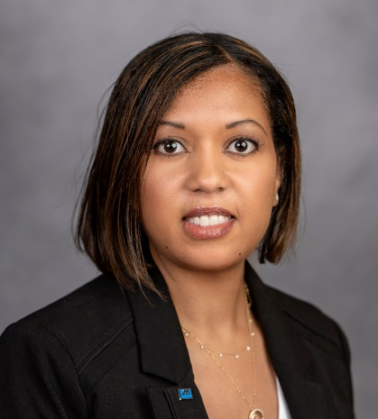
Ms. Thomas is a program manager for Definitive Logic (DL), an IT integration company based in Arlington, Virginia. She directs a 15-member, geo-dispersed team providing Oracle Human Capital Management (HCM) Cloud implementation and integration services for the Air Force Talent Management community. This effort directly supports Digital Transformation efforts to consolidate and modernize the 100+ Human Resources Air Force legacy systems into the Cloud for 1.2M users.

Ms. Thomas is a United States Air Force veteran, commissioned at the University of South Florida in 1997. She served as Deputy Chief of Protocol for the U.S. Pacific Command and the Chief of Joint Visitors Bureau for Headquarters, RESOLUTE SUPPORT in Kabul, Afghanistan. She deployed in direct support of the 2013 Presidential Inauguration and commanded the 366th Force Support Squadron at Mountain Home Air Force Base, Idaho. She last served at Headquarters Air Force, Pentagon, where she implemented Human Resource Information Technology supporting governance, customer relationship management, human capital management, identity management and integration of all talent management projects across Air Force Talent Management community.

Mr. Thomas earned a master’s degree in Business Administration from Webster University in 2004, and a bachelor’s degree in Business Administration in 1997. She is a certified Project Management Professional and Scrum Master since 2018. She also works with the Board of Directors for the Washington D.C. Chapter of the Project Management Institute. Ms. Thomas currently resides in Arlington, Virginia.

